You should be able to identify behaviors of graphs:

| **Behavior** | **How to Find it on a Graph** |
| --- | --- |
| $x-$**intercept** | Where the graph crosses or touches the $x-$ axis. |
| $y-$**intercept** | Where the graph crosses or touches the $y-$ axis. |
| **Domain** | The set of all inputs/ $x-$ values of the relation. (i.e. Look for area of the graph that don’t exist first and then write the areas that do exist in interval notation). |
| **Range** | The set of all outputs/ $y-$ values of the relation. (i.e. Look for area of the graph that don’t exist first and then write the areas that do exist in interval notation). |
| **Intervals of Increase** | The intervals of $x-$ values, that when tracing a graph (from left to right), your pencil moves upwards, show the graph is increasing. |
| **Intervals of Decrease** | The intervals of $x-$ values, that when tracing a graph (from left to right), your pencil moves downwards, show the graph is decreasing. |
| **Constant Intervals** | The intervals of $x-$ values, that when your pencil traces a horizontal line, then show the graph remains constant. |
| **Relative/Local Maximum** | Where the graph changes from increasing to decreasing. |
| **Relative/Local Minimum** | Where the graph changes from decreasing to increasing. |
| **Absolute/Global Maximum** | The highest point on the graph. |
| **Absolute/Global Minimum** | The lowest point on the graph. |

Example: For each of the following graphs, find the given characteristics.

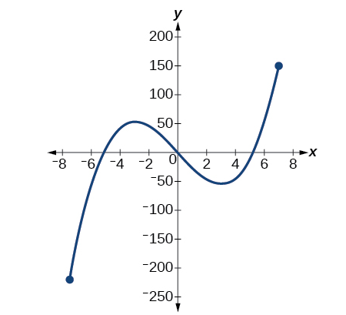

Values of *x* for which $f\left(x\right)=-50$

Is $f(-1)$ positive or negative?

Domain:

Range:

$x-$ intercept(s):

$y-$ intercept(s):

Relative/Local Maximum:

Relative/Local Minimum:

Absolute/Global Maximum:

Absolute/Global Minimum:

Constant Interval:

Interval of Increase:

Interval of Decrease:

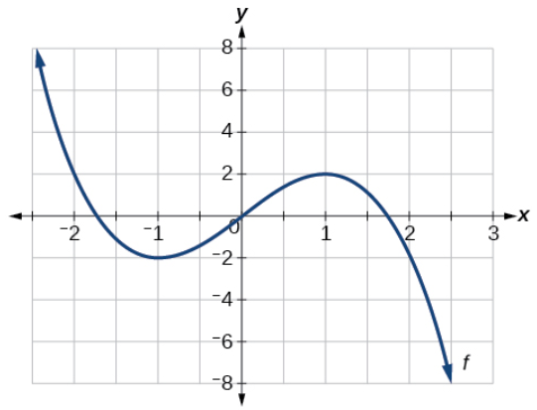

Values of *x* for which $f\left(x\right)=2$

Is $f(-1)$ positive or negative?

Domain:

Range:

$x-$ intercept(s):

$y-$ intercept(s):

Relative/Local Maximum:

Relative/Local Minimum:

Absolute/Global Maximum:

Absolute/Global Minimum:

Constant Interval:

Interval of Increase:

Interval of Decrease: